
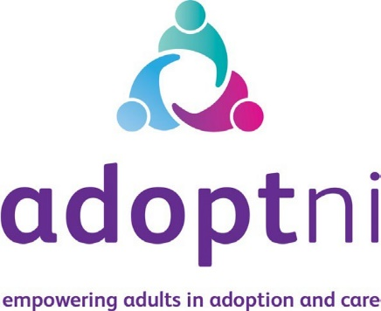

Job Application

Family Tracing & Records Officer

Full time Ref: MBMLWFT-FTRO-26-07-17
Part time Ref: MBMLWPT-FTRO-26-07-17

Applicants must complete the application form in either font size 12, or legible block capitals using black ink.

Closing date for applications:
Friday 7th August 2026 5PM

JOB APPLICATION FORM
POSITION APPLIED FOR:
Job Title:
Ref No:
Where did you see this post advertised?

1. APPLICANT DETAILS
Title: | Surname | Forename
Home Address:
Post Code:

Contact Details:
Daytime no:
Evening no:
Mobile no:
Email address:
National Insurance No:
Town of birth:
Country of birth:
Do you hold a current driving licence? | Yes / No:
How much notice do you need to give your current
employer?

Please start with your most recent employer.
2. EMPLOYMENT RECORD – 10 year job history
Employer Name:
Address:
Job Title: | From: / / | To: / /
Brief description of duties:
Reason for leaving / changing:

Employer Name:
Address:
Job Title: | From: / / | To: / /
Brief description of duties:
Reason for leaving / changing:

Employer Name:
Address:
Job Title: | From: / / | To: / /
Brief description of duties:
Reason for leaving / changing:

Employer Name:
Address:
Job Title: | From: / / | To: / /
Brief description of duties:
Reason for leaving / changing:

Employer Name:
Address:
Job Title: | From: / / | To: / /
Brief description of duties:
Reason for leaving / changing:

Employer Name:
Address:
Job Title: | From: / / | To: / /
Brief description of duties:
Reason for leaving / changing:

Employer Name:
Address:
Job Title: | From: / / | To: / /
Brief description of duties:
Reason for leaving / changing:

Employer Name:
Address:
Job Title: | From: / / | To: / /
Brief description of duties:
Reason for leaving / changing:

3. EDUCATION :
Name of school/  college | Qualification  / Level | Subject | Grade  Awarded | Date  Gained
4. FURTHER / HIGHER EDUCATION:
Include information on undergraduate and postgraduate degrees, diplomas, evening and correspondence courses, vocational or technical courses.
Name of University/College | Qualification  / Level | Subject | Grade/  Classification Awarded | Date Gained
5. PROFESSIONAL MEMBERSHIPS
Please provide details of any professional memberships you hold?

6. ESSENTIAL ELIGIBILITY CRITERIA

6.1) By the closing date for applications, candidates must have:
- Recognised qualification in genealogy or related research discipline and 2+ years post qualifying experience,
OR
Other relevant demonstratable qualification with 3 years post qualifying experience
6.2) Regular in person access to public records offices in Northern Ireland.
(Please continue on a separate sheet if necessary)

7. Desirable Criteria

7.1) Genetic genealogy experience.
7.2) Knowledge of adoption tracing work for adults.
(Please continue on a separate sheet if necessary)

8. Special Requirements
As an Equal Opportunity Employer, we wish to ensure that all applicants have the opportunity to perform to the best of their ability in either a test or interview situation.

Please let us know if you require any reasonable adjustments, or arrangements to enable you to attend the interview.

9. Referees
If you are responding to a public advertisement, please provide the required information for two persons not related to you, to whom references may be sent. One of your referees must be either your current or previous employer (if any) and both should be able to comment on your ability to carry out the particular tasks of the job.

If you do not wish us to contact your present employer, please provide
your most recent previous employer:

Current or previous employer (if any) | Other employer or nominated character referee
Name:  Job title:  Name of organisation:  Address (including post code):  Contact telephone: | Name:  Job title (if applicable):  Name of organisation (if applicable):  Address (including post code):  Contact telephone:

10. DECLARATION
- I have read and understood the information provided in the Candidate Information Booklet.
- I undertake to inform the Adopt NI in writing of any changes in my circumstances which may occur between the date of my application and any possible date of appointment.
- The responses detailed in this application form are true and accurate to the best of my knowledge and belief. I understand that if I am found to have suppressed any material fact or to have given false answers, I will be liable to disqualification or, if appointed, to dismissal.
- I confirm I am aged 16 or over.
- I give my consent for a criminal record check to be carried out as detailed in the ‘Vetting’ section of the Candidate Information Booklet.

Signed: Date:

Please return the completed application via:

Email: india@adoptni.org

Post: FAO Ciara Scully - Chief Executive Officer
Adopt NI
Ground Floor
Unit 2 (Pilots View)
18 Heron Road Belfast
BT3 9LE

Your application must be received no later than: Friday 7th August at 5PM

