INVITATION TO TENDER FOR

Counselling / Psychotherapy Sessional Panel
2026-2027

Adopt NI is an independent registered charity established in 1989. Our main priority is to support any adult impacted by the lifelong journey of adoption or separation from their family of origin (birth mothers, adult adoptees, adopters, and siblings). For 30+ years we have delivered support services, counselling, tracing and intermediary services for any adult linked to the adoption triangle. Adopt NI supports individuals who have been impacted by Mother and Baby Institutions, Magdalene Laundries, Workhouses and their pathways and practices in Northern Ireland.

We are inviting tender applications to build a regional sessional panel from qualified, experienced counsellors or psychotherapists to deliver talking therapies on a sessional basis. Successful applicants will provide the service as self-employed, independent contractors. We particularly welcome applications from the SHSCT area and from those applicants with their own premises and/or willing to travel.

Tender application form and relevant documents are attached in the links.

Completed application forms and documentation must be returned by Thursday 5Th February 5PM 2026. Late applications will not be considered.

Please return completed applications by email, marked private and confidential and stating ‘Tender for sessional counsellors/ psychotherapists’ to: india@adoptni.org

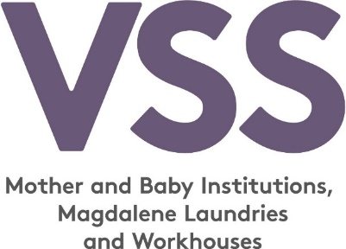
FUNDED BY

