INVITATION TO TENDER FOR

Sessional Support
2026-2027

Adopt NI is an independent registered charity established in 1989. Our main priority is to support any adult impacted by the lifelong journey of adoption or separation from their family of origin (birth mothers, adult adoptees, adopters, and siblings). For 30+ years we have delivered support services, counselling, tracing and intermediary services for any adult linked to adoption.

We are inviting tender applications to build a regional sessional panel from qualified, experienced therapeutic support workers to develop and deliver tailored support bespoke to the needs of our services users. We are interested in hearing from a wide range of applicants including those with experience of art, eco, creative and somatic facilitation, adoption related support as well as from those with training development and delivery experience for groups. Successful applicants will provide the service as self-employed, independent contractors.

Tender application form and relevant documents are attached in the links.

Completed application forms and documentation must be returned by Thursday 17th April 2026 at 5pm. Late applications will not be considered.

Please return completed applications by email, marked private and confidential and stating ‘Tender for sessional support’ to: india@adoptni.org

FUNDED BY
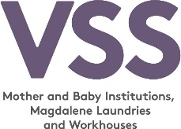

IIIi

